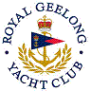 | Royal Geelong Yacht Club Inc.  Est 1859
Trophy Deed of Gift.

Trophy: | Ruth Plummer Perpetual Trophy
Presented by: | Ruth Plummer
Date: | 2003
For: | Cadet Whose Activities Embody the Spirit of the Cadet Fellowship
Remarks / Revisions
Click here for a List of Recipients
